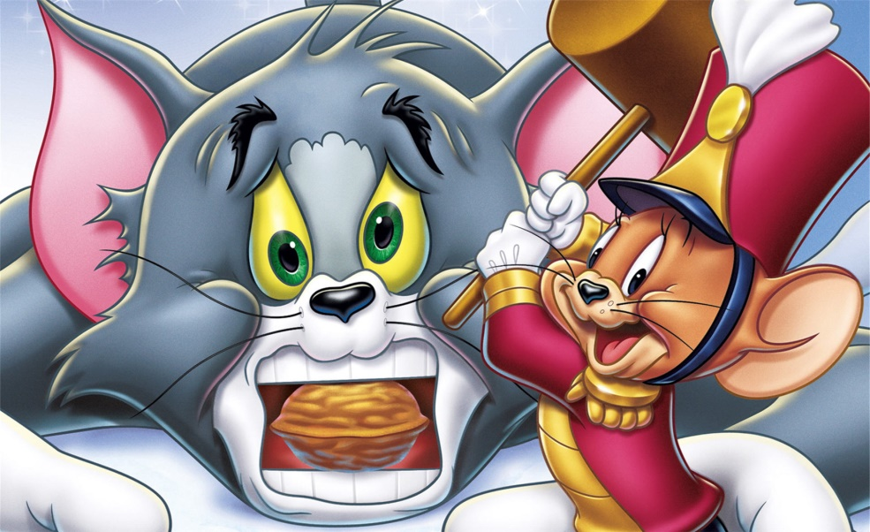

**Merry Christmas & Happy New Year! ☺**

**From: Ninang Lhen**

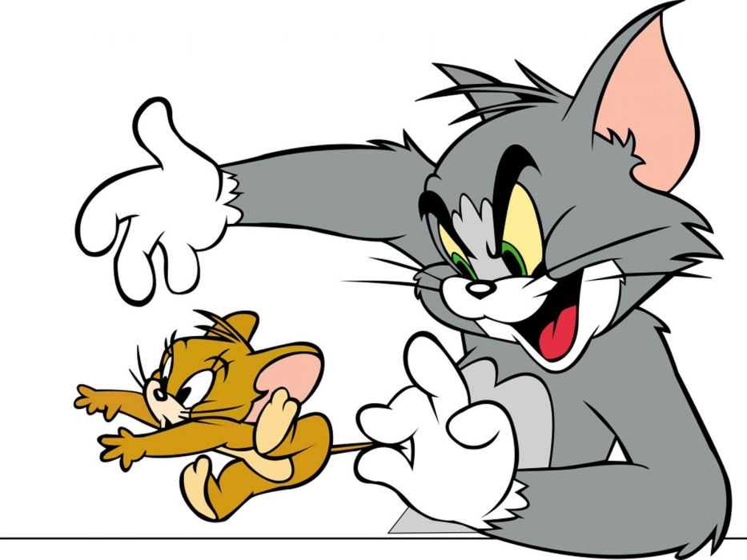

**Merry Christmas & Happy New Year! ☺**

**From: Ninang Lhen**

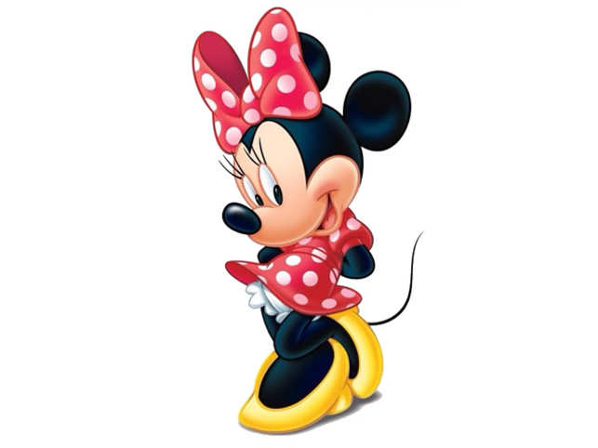

**From: Ninang Lhen**

**Merry Christmas & Happy New Year! ☺**

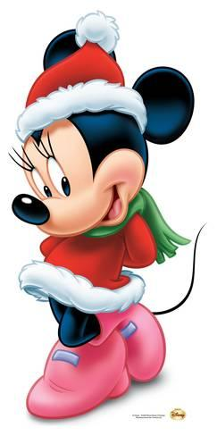

**From: Ninang Lhen**

**Merry Christmas & Happy New Year! ☺**